**PemWeb Tugas 5 – Form**

**Latihan 1**

**Code :**

<html lang="en">

<head>

<title>Latihan</title>

</head>

<body>

<form>

<center>

<h1>Form data mahasiswa</h1>

<hr>

<table>

<tbody><tr>

<td>Nama anda</td>

<td>

: <input type="text" name="namasiswa" id="nm" size="20">

</td>

</tr>

<tr>

<td>Jenis kelamin</td>

<td>

: <input type="radio" name="jeniskelamin" id="jk" value="L">Pria

<input type="radio" name="jeniskelamin" id="jk" value="P">Perempuan

</td>

</tr>

<tr>

<td>Hoby</td>

<td>

: <input type="checkbox" name="musik" id="mk">Musik

</td>

</tr>

<tr>

<td></td>

<td>: <input type="checkbox" name="jalan" id="jl">Jalan</td>

</tr>

<tr>

<td></td>

<td>: <input type="checkbox" name="baca" id="bc">Baca</td>

</tr>

<tr>

<td>Agama</td>

<td>

: <select name="agama" id="ag">

<option value="islam">Islam</option>

<option value="kriste">Kristen </option>

<option value="hindu">Hindu</option>

<option value="budha">Budha</option>

</select>

</td>

</tr>

<tr>

<td>Asal sekolah</td>

<td>

: <input type="text" name="asalsekolah" id="as" size="30">

</td>

</tr>

<tr>

<td>Keterangan</td>

<td>

: <textarea name="keterangan" id="ket" cols="34" rows="5"></textarea>

</td>

</tr>

</tbody></table>

<hr>

<input id="sub" type="button" value="kirim">

<input type="reset" value="reset">

</center>

</form>

</body>

</html>

**Screenshot :**

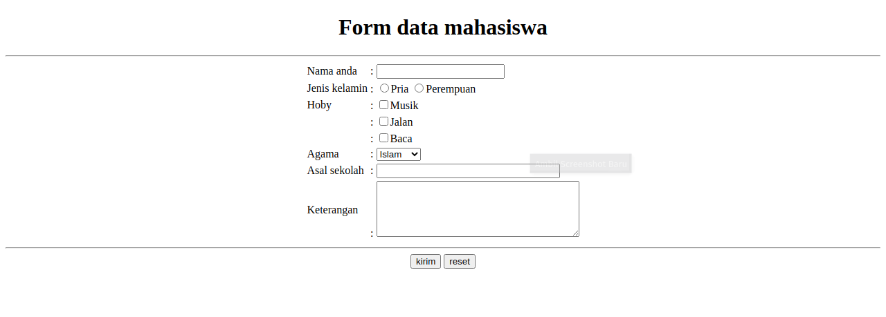

**Latihan 2**

**Code :**

<html lang="en">

<head>

<meta charset="UTF-8">

<meta http-equiv="X-UA-Compatible" content="IE=edge">

<meta name="viewport" content="width=device-width, initial-scale=1.0">

<title>Latihan</title>

</head>

<body>

<form id="myform" action="" s="">

<center>

<h1>Form input data KTP</h1>

<hr>

<table>

<tbody><tr>

<td>NIK </td>

<td>

: <input type="text" name="nik" maxlength="16" id="nik" size="30">

</td>

</tr>

<tr>

<td>Nama </td>

<td>

: <input type="text" name="nama" id="nm" size="30">

</td>

</tr>

<tr>

<td>Tempat/Tgl Lahir </td>

<td>

: <input type="text" name="tempat" id="tmp" size="9">

<input type="date" name="tanggal" id="tgl">

</td>

</tr>

<tr>

<td>Jenis kelamin</td>

<td>

: <input type="radio" name="jeniskelamin" id="jk" value="L">Pria

<input type="radio" name="jeniskelamin" id="jk" value="P">Perempuan

</td>

</tr>

<tr>

<td>Gol. Darah</td>

<td>

:

<select name="gologandarah" id="gd">

<option value="-">-</option>

<option value="O">O</option>

<option value="A">A</option>

<option value="AB">AB</option>

</select>

</td>

</tr>

<tr>

<td>Alamat</td>

<td>

: <input type="text" name="alamat" id="alm" size="30">

</td>

</tr>

<tr>

<td align="center">RT/RW</td>

<td>

: <input type="text" name="RTRW" id="rtrw" size="30">

</td>

</tr>

<tr>

<td align="center">Kel/Desa</td>

<td>

: <input type="text" name="desa" id="ds" size="30">

</td>

</tr>

<tr>

<td align="center">Kecamatan</td>

<td>

: <input type="text" name="kecamanat" id="kec" size="30">

</td>

</tr>

<tr>

<td>Agama</td>

<td>

: <select name="agama" id="ag">

<option value="islam">Islam</option>

<option value="kriste">Kristen </option>

<option value="hindu">Hindu</option>

<option value="budha">Budha</option>

</select>

</td>

</tr>

<tr>

<td>Status Perkawinan</td>

<td>

: <select name="statusperkawinan" id="sk">

<option value="KAWIN">KAWIN</option>

<option value="BELUM KAWIN">BELUM KAWIN</option>

</select>

</td>

</tr>

<tr>

<td>Pekerjaan</td>

<td>

: <input type="text" name="pekerjaan" id="pk" size="30">

</td>

</tr>

<tr>

<td>Kewarganegaraan</td>

<td>

: <select name="kewarganegaraan" id="kwg">

<option value="WNI">WNI</option>

<option value="WNA">WNA</option>

</select>

</td>

</tr>

<tr>

<td>Berlaku hingga</td>

<td>

: <input type="text" name="berlakuhingga" id="bh" size="30">

</td>

</tr>

<tr>

<td>Foto Resmi</td>

<td>

: <input type="file" name="fotoresmi" id="fr">

</td>

</tr>

<tr>

<td>Tanda dangan</td>

<td>

: <input type="file" name="tandatangan" id="ttd">

</td>

</tr>

</tbody></table>

<hr>

<input type="submit" value="kirim">

<input type="reset" value="reset">

</center>

</form>

</body>

</html>

**Screenshot :**

